1. Client image from admin is different than client image from app (in admin we need to see his face for identification)
2. In profile age is not accurate
3. Change reservation date to maximum 48 hours (input by CEO user)
4. Ceo can close all services for maintenance or events at any day or any hour
5. Ceo can send a message to all users on the app from the control panel
6. Search even by “zia” or any letters from the name
7. New tab for management users to reserve to users from control panel (clients can reserve services from app, I want the management users from the admin panel to be able to reserve services for clients)
8. In reports: reservations search by service + date
9. In reports: reservations color the results “red for the passed, green for the upcoming”
10. Check out button for reception (the reception tab should have search, check-in check out buttons so they can search for clients name and status, check in client, checkout client)
11. Add a button for packages: can book online, can subscribe online (from the app clients can subscribe to a service, reserve a time slot for that same service)
12. In subscription: instead of typing in the date open a calendar
13. Change name of discount “special discount”
14. Discount is a drop down increment of 5
15. William moutran subscription is not showing in reports (I created a new user, but they don’t show up in reports)
16. Subscription ending: active
17. Subscription ended: inactive
18. 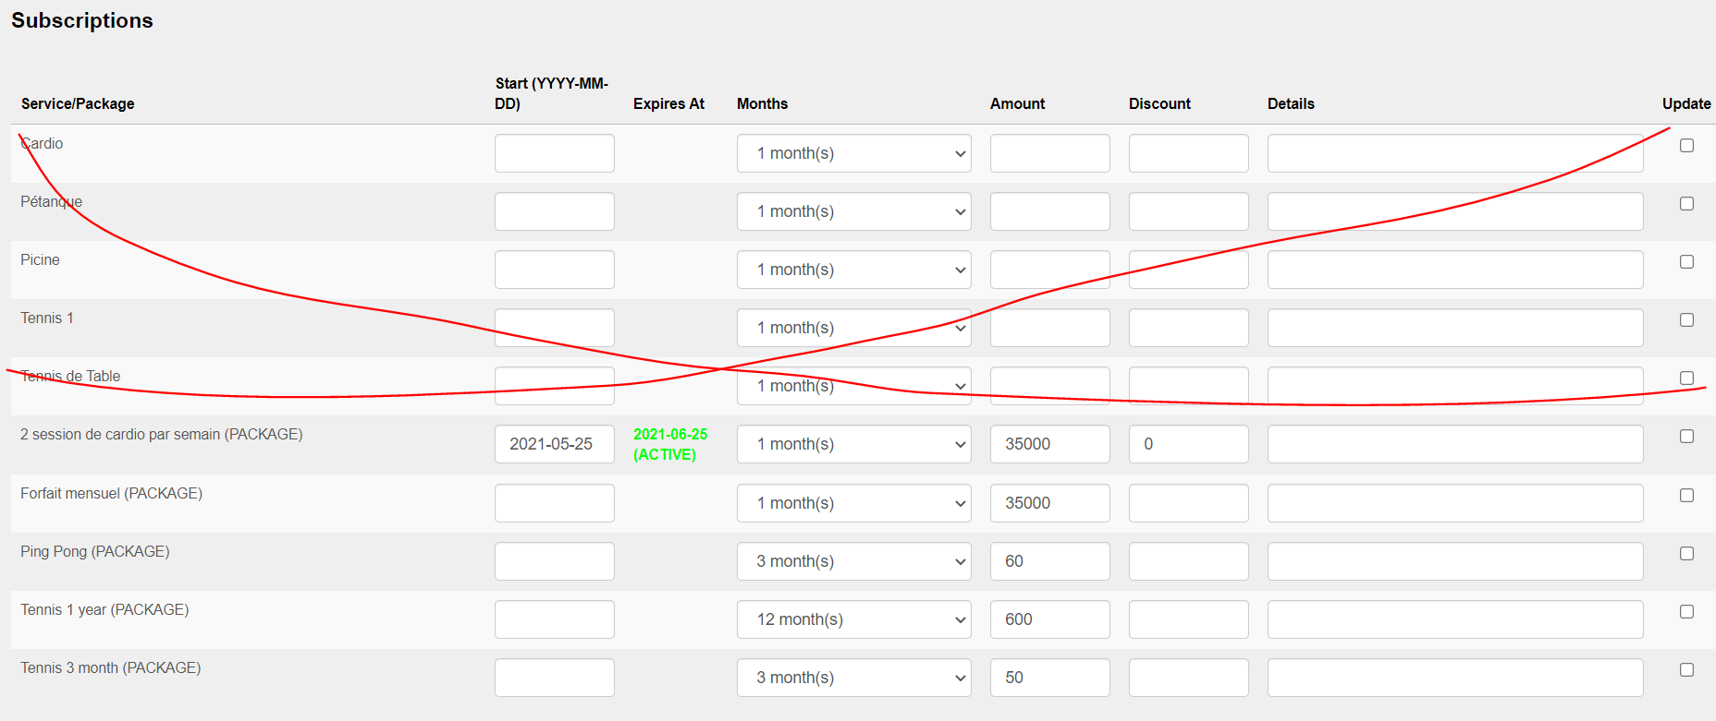
19. New tab for family members: instead of entering in every user to add family members (in admin panel, when reservation user is trying to create a new user, I want him to be able to add family members for this user in an easy way, currently he has to enter to every user and add their family members)
20. Reservations = (client management)
21. Under reservations: move users who created an app account but did not request a package to a new tab (this is the users found in the home page)
22. Under: reservations services and packages move to a new TAB under CEO (currently reservation user can create packages and services, I want only CEO to have access to create packages and services)
23. Only CEO can make special discount
24. Only CEO can change AMOUNT while subscribing a new user
25. How can I backup the data daily?
26. Reservations: can see inactive users so they can reactivate users
27. Reservations: change name of users to “Active users”
28. Reservations can search in all users
29. Reservations: active users, inactive users, subscription request
30. Add report: mobile downloads
31. Reception can reserve services for users
32. Hide home page for now
33. Management can Change the subscription for users from I service to another can pay the difference or get payed the difference (later on)
34. Ceo can pause a user to deny check-in
35. new user: trainer can only see reports
36. reports: client inside should show the image in the report
37. add second language “French”